Renegade Mod Tools

Your First Map
By Greg Hjelstrom

This tutorial should be enough to get a basic mod with a map up and running. The map will not be textured and it will not include the C&C buildings; this tutorial is just the basics!

Getting everything installed

- Install Renegade, make sure you’ve played it at least once!
- Download and install Gmax.
- Register Gmax
- Dowload and install the Renegade Public Tools
- Go to your start menu and run RenX

Create a Mod Directory to work in.
- Start up the Level Editor.
- You will be presented with this menu, click the “New” button and name the Mod you will be working on. A Mod for renegade is a collection of maps, objects, and game settings that combine to form (possibly) a completely new multiplayer game.
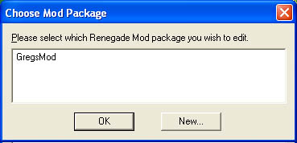
- Now, when I created “GregsMod” above, the level editor created a directory named GregsMod for me in the LevelEdit install directory. ALL assets that you want to use in your mod should be placed in this directory (or in subdirectories of this directory)

Creating a terrain model in RenX.
- Run RenX by clicking the shortcut in your start menu under RenegadeTools
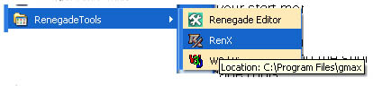
- A terrain is just a collection of static mesh. Lets create a big box that will be the “ground” for our test level. I’ve created a box that is 100m x 100m x 10m with 30 divisions for the width and length.

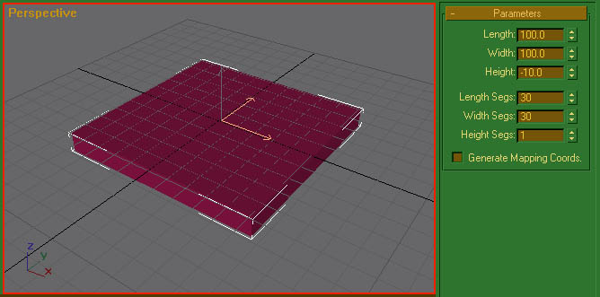
- Next, I’ll convert the box into an editable mesh so that we can start working with it. Right click on the box and select “convert to”->”editable mesh” from the pop-up menu.
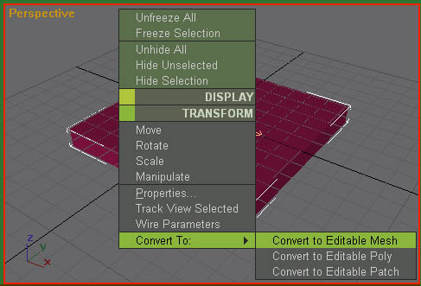

- Now we’ll go to the modify panel and start dragging vertices and dump a bunch of objects into the level. If you look closely, you can see a 1m x 1m x 2m box that I created to get an idea of how big the character is in relation to the stuff I’m modeling.

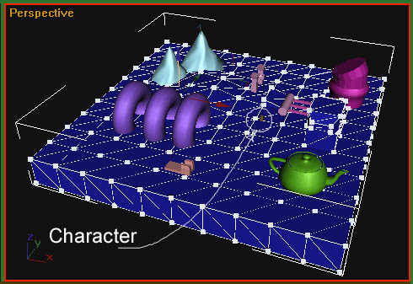

- Now we need to make our meshes collideable so that the characters will not fall or walk through them in the game. Go to the utility panel (the tab with a hammer on it) and open up the W3D Tools utility. You’ll want to enable Physical, Projectile, and Camera collision on most of your geometry. Select all of your meshes and click the check-boxes until they look like the following:
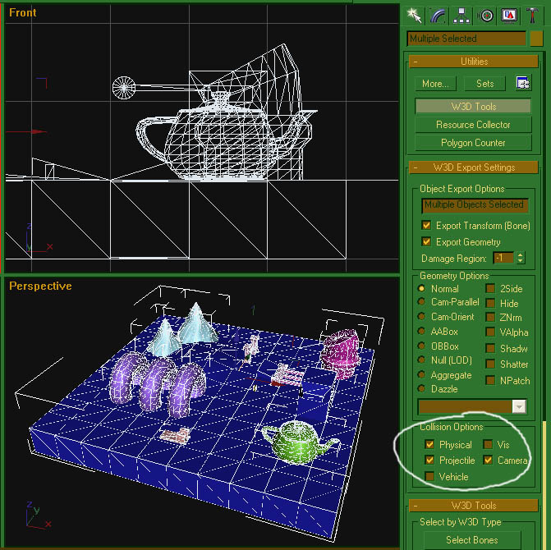

- Now we’re ready to try the level out in Reneagde. Go to the file menu and select “Export”. Select W3D in the “Save As Type” option. Export your file into your mod’s directory that was created when you ran the level editor. On the export options dialog select the “Renegade Terrain” option.

Creating a Level With Your New Terrain
- Load up the editor again and select your mod.
- Go to the presets tree on the right hand side of the level editor’s user interface and open up the terrain group.

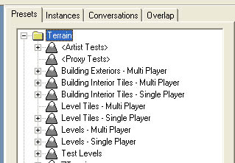

- Now create a new “Preset” for your terrain by clicking the “Add” button at the bottom of the preset tree.
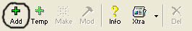

- The “Edit Object” dialog will pop up. Give your preset a name; I usually use the same name as the W3D file I exported. Then go to the settings pane and select its model. You need to make sure its model is in or below your Mod’s sub-directory.

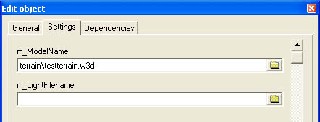

- Now, click the OK button and you have created a preset which uses your terrain’s W3D file. Whenever you want to use that terrain in a level, just select it and click the “Make” button (down near the “Add” button). Below is a screenshot of the level-editor after I’ve created an instance of my terrain.
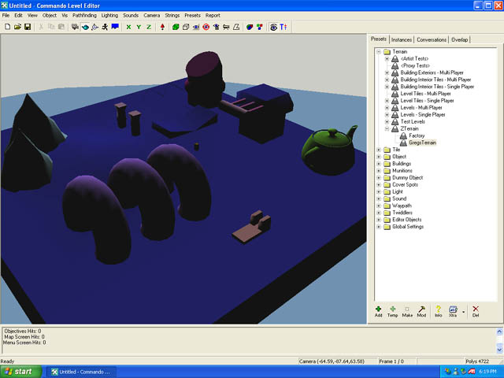

- You can test your terrain a little by flying the camera down near the ground (using the numeric keypad) and then clicking on the “walk through mode” toolbar button (top center of the level editor user interface).

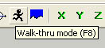

- Below is a shot of me running around in the level. If you fall through the ground, you need to go back to RenX, select the mesh you fell through, and set its collision options.
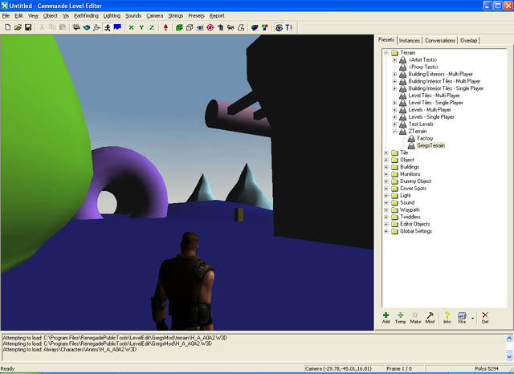

- The next step is set your level up for multi-play. To do this, you need to add GDI and Nod spawners around the level. Go to the preset tree, open up Objects->Spawners->StartupSpawners. “Make” a bunch of GDI and Nod spawners in your map.
- Now we’re ready to run this level in Renegade. Go to the “File” menu and save your level and export your mod package. Your mod package is a pkg file in the Data directory for Renegade. To let your friends run your mod, just give them this file.

Running your Level in Renegade
- Run Renegade
- Select Multiplayer Lan.
- Host a game.
- In the multiplayer options screen, you need to make sure you select the following things:
  - 1 player (so you can test without the “Gameplay Pending” problem)
  - Disable the “dedicated server” option
  - On the map cycle screen, select your mod package and map
- You should now be able to play on your map!

